**Possible reasons for cube leaking /not pumping out.**

1 – Customer / End user moved machine before purging.

**Possible Reason** - Water spilling out of drip tray when machine moved. The machine has a shallow drip tray so the machine needs to be purged before moving. Press the purge button.

2 – Machine not placed on level surface

**Possible Reason -** Water spilling out of drip tray before float switch operates – the machine needs to be placed on a level surface

3 – Machine not carried level

**Possible reason** – remaining water spilling out of drip tray onto inside of machine – ensure the machine is carried level and purged before moving

4 – Outlet hose kinked or squashed

**Possible Reason** – Fully unwrap hose and place into a free running drain or bucket – if the hose is kinked the machine should stop with an ER9 error message. To clear an error message, unplug the machine, cure the fault and plug the machine back in.

5 – Pump filter assembly lid not tightened down, or sealing ring not present or damaged.

**Possible Reason -** Pump not creating suction to suck water out of drip tray

**Solution -** Check sealing ring present and lid tightened down by hand – see photos below. If this is not tightened down the machine should stop with an ER9 error message. To clear an error message, unplug the machine, cure the fault and plug the machine back in.

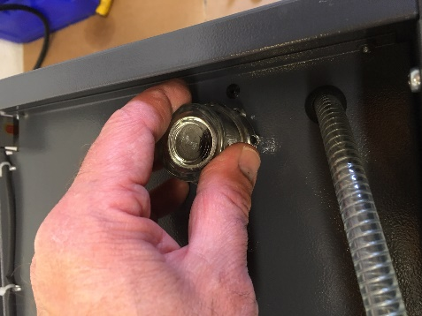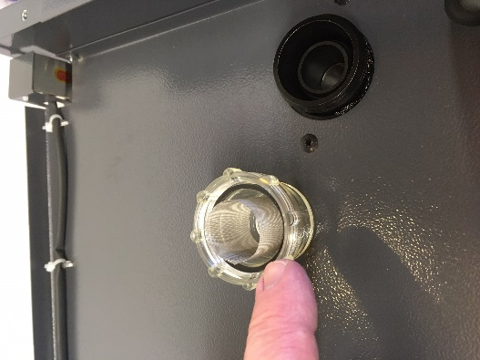

6 – Pump filter blocked

**Possible Reason -** Pump filter too blocked to allow water to pass through. Dirt can be seen through clear housing.

**Solution –** Unscrew pump filter housing and remove filter inside. ( see pictures above ) Clean filter in water and replace. Check sealing ring present and lid tightened down by hand. If the filter is completely blocked, the machine should stop with an ER9 error message. To clear an error message, unplug the machine, cure the fault and plug the machine back in.

7 – Pump not pumping water but running – i.e you can hear the pump making a noise but not pumping water out

**Possible Reason** - Pump needs priming

**Solutions** - Unstick pump by pressing purge button a few times, until you can feel air / water coming out of hose end.

If this does not get water coming out of the outlet pipe, then unscrew filter assembly, pour water into housing ( outside ring – see photo below ) and purge pump until water gets sucked into pump.

This fault should cause the machine to stop with an ER9 error message– To clear an error message, unplug the machine, cure the fault and plug the machine back in.

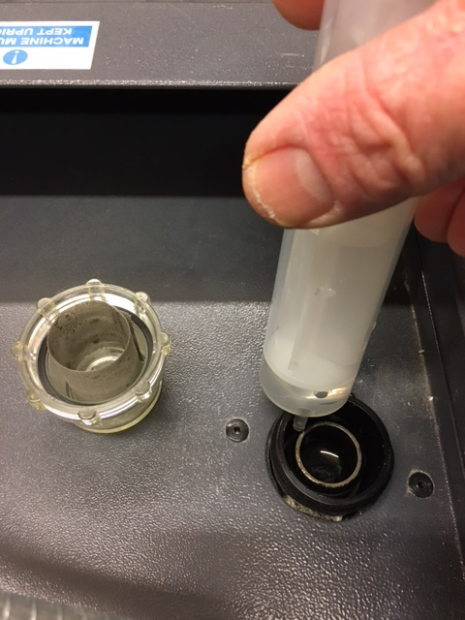

8 – Float switch not operating pump

**Possible Reason** – pump sticking or failed

**Solution** - To test the float switch, plug the machine into the mains power, remove the main air filter from the machine, and using a long stick or rod, lift up the float switch for a few seconds. You should hear the pump start working, and operate for 25 seconds, with a countdown on the touchpad display – see photo below

The float switch is a white donut which slides up and down on a shaft – see below.

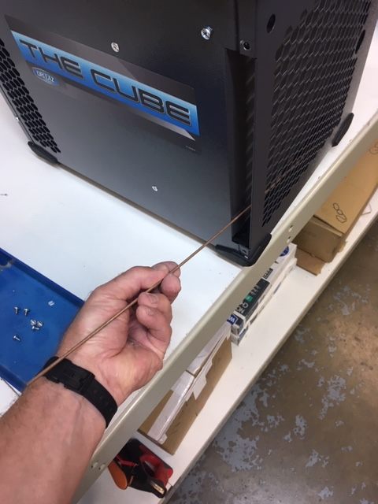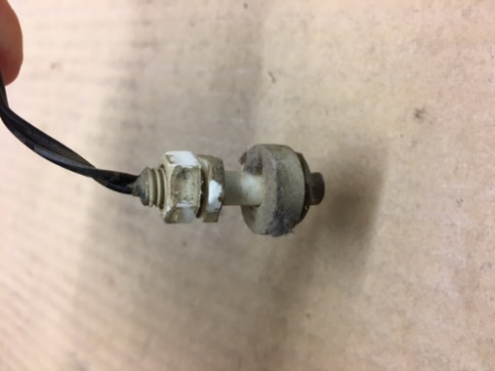

This ring slides up and down the shaft

If you cannot access the float by this means, then remove the FILTER end panel of the machine – 8 short screws. This will reveal the coil and the drip tray and float switch – see below

Note - There are two different versions of the drip tray and float switch mounting – see below, but both work in the same way

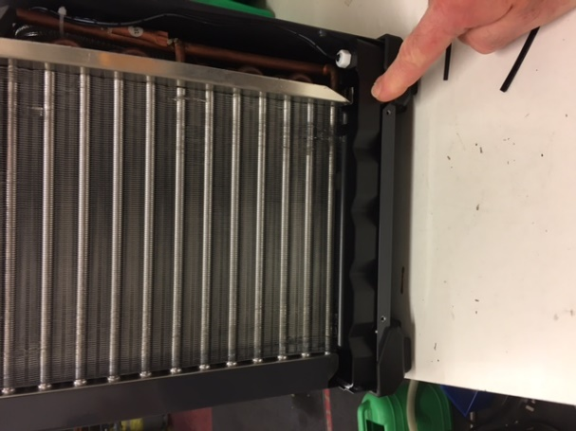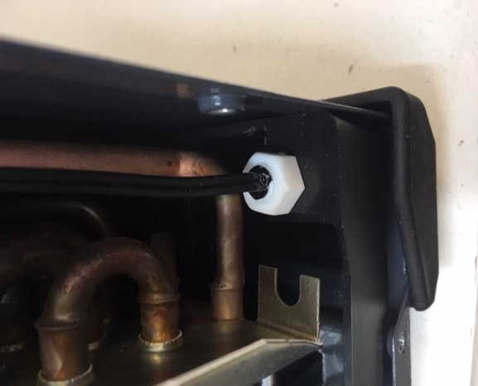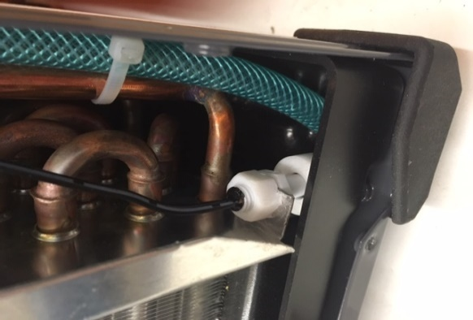

With the end cover removed you can lift up the float switch using a finger to check for operation.

Check that it operates freely and does not stick or rub on anything – i.e the side of the drip tray or dirt on the float.

If the float rubs on the drip tray and is mounted on the metal coil, the metal bracket can be bent slightly to angle the float switch away from the side of the drip tray

The float over time may get dirty, causing it to stick and not rise up when water is in the drip tray. ( see dirty float - below )

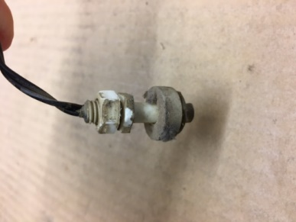

The float can be gently removed from its bracket by undoing the top nut, cleaning using soap and water and a small brush and remounting.

With the machine powered up ( it does not have to be running ) , the float back in place and the outlet hose in a bucket, water can be poured down the front of the coil. This should fill up the drip tray and lift the float switch, causing the pump to operate, and pumping out the water.

If this happens then the complete pump and float system is working correctly.

Remount the end cover with the 8 screws and slide in the air filter.